COCOMO II model has three constituent estimation models, which can be used in combination to suit the estimation requirements. These are:
1. Application composition model: The model 'uses size estimation using object points and then uses these to find out the development object points. It uses productivity figures to then calculate the effort. .
2. Early design model: This is an estimation done using information available in the early part of a project when not much detail is known.
3. Post-architecture model: This is the most detailed estimation method and assumes that the system architecture is known, and that information on the various cost drivers of the system is available.

In addition to these three models, COCOMO II has a companion set of other models that together form a suite --these other companion models are still being evolved and calibrated. We now discuss the three estimation models that constitute COCOMO II.
Usage of the three COCOMO II estimation models for various project situations is as follows:
- For application composition projects, the application composition model is used
- For other projects, such as system integration, application generator, infrastructure software projects, a combination of all the three CO COMO II models is used ("tailored mix")
- For the prototyping phase (if any) the application composition model is used
- For the early stages after prototyping, such as exploration of architectural options, incremental development, etc., the early design model is used
- Once the project architecture is decided, the post-architectural model is used.
------------------------------------------------------------------------------------------------------------------
I Application Composition Model
This model is to be used for quickly developed applications made from interoperable components. It can also be used to estimate for the "prototyping" phase of application generator development, infrastructure software and systems integration projects.
Here, the size is first estimated using object points. Object points are considered suitable for such applications since the objects (screens, reports, 3GL components) are easy to identify and count.
The new object points are computed next--- these are the object points that will need to be developed and differ from the object point count because there may be re-use.
New object points (NOP) = Object points * (100 -% re-use)/100
Effort calculation for a given object point count is the next step. This is done using a productivity rate that gives the NOP per person month.
Productivity (PROD) = NOP/person-month
PROD values should be computed by using the NOP and total person-months from the past projects in similar environments. COCOMO II application composition model gives the following table containing values of PROD based on their data and experience.

Developer’s experience and capability ICASE maturity and capability | PROD(NOP/person-month)
Very low | 4
Low | 7
Nominal | 13
High | 25
Very high | 50
The effort estimate in person months is then computed as
Effort Person-months = NOP/PROD
Note that the application composition model assumes that size is linearly related to effort.
---------------------------------------------------------------------------------------------------------------
II Cost Estimation
In addition to the estimation of size, effort and schedule, estimation for project includes estimating costs. This includes the costs due to the effort to be put by the project team and other costs. This is an activity the project manager does based on project specific inputs and examples of costs of other such similar projects. Organizations usually have their internal project budget formats that have the various cost heads to be considered. Costs to consider include:
- Personnel costs.
- Hardware costs
- Software costs
- communications costs
- Travel and stay costs.
- Training
- other costs
  - costs for subcontracted work
  - consultancy charges for domain experts
  - special equipment (purchase/hiring) costs
  - costs for infrastructure built specifically and only for the project
A Costing Sheet (like the one in Figure below) can be developed and used for estimating the costs for a project.
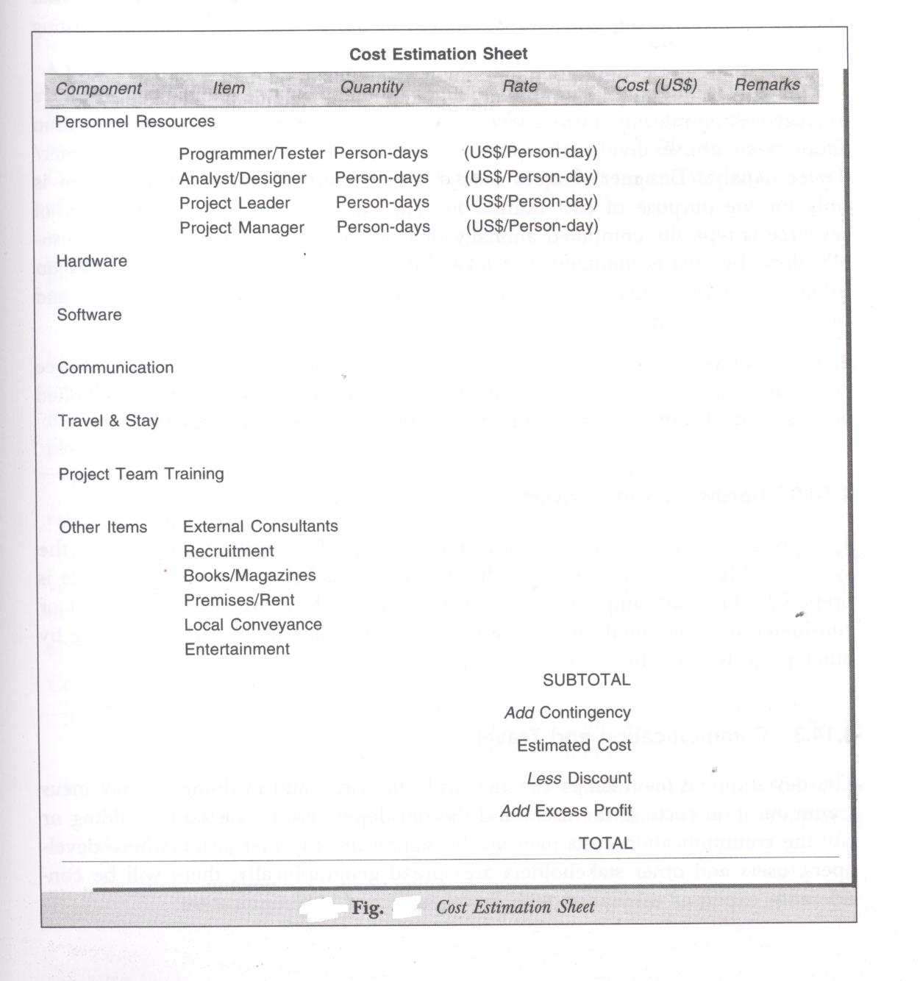

1 Personnel Cost
This is the cost incurred by the development organization for assigning developers to a project. Two pieces of information are required for computing the personnel cost, the amount of effort (in person days or person months or person years) that persons assigned to the project are required to put in the project and the costing rate for the individuals.
Though the salary for each individual is different, organizations typically have average costing rates for various levels and roles in the project. The cost estimation sheet given above divides the project team into four categories: Programmer/ Tester, Analyst/Designer, Project Leader and Project Manager. This division is only for the purpose of cost estimation. The costing rates for each category of resource is typically computed annually or twice a year. The computation is usually done by cost accountants and takes into consideration the % time spent on projects by each category of resource, the typical salary of a resource category and the allocated/apportioned overhead costs of the organization.
The estimated effort calculated earlier is divided between the various resource categories. The estimated effort for each personnel resource category is multiplied with the rate to arrive at the cost of each personnel resource category.

2 Hardware and Software
The project needs to use hardware and software for creating and testing the system. All hardware and software that is required is listed and a cost estimate is prepared. Hardware and software costs are either fully charged to the project or considered as a "notional rental" charge, if the hardware and software is usable by other projects after the project is completed.

3 Communication and Travel
The development team keeps in touch with the users, and in doing so may incur communication costs. If the users and the developers are in the same building or city the communication costs may not be significant. In other cases, where developers, users and other stakeholders are spread geographically, there will be considerable expenses associated with travel, stay and communication.

Communication costs can be estimated based on the total expected duration of estimated long distance calls and the typical rate of such long distance calls.
Travel costs can be estimated based on the trips to be made by the project team members, the duration of the stay, the transportation fare (air fare, train fare, etc.) and the average expenses per day while on tour.

4 Project team Training
In many project specific training will have to be arranged. This may require external trainers, venue and other infrastructure required for the training. Costs of these may be significant enough to be estimated for and added to the cost of the project.

